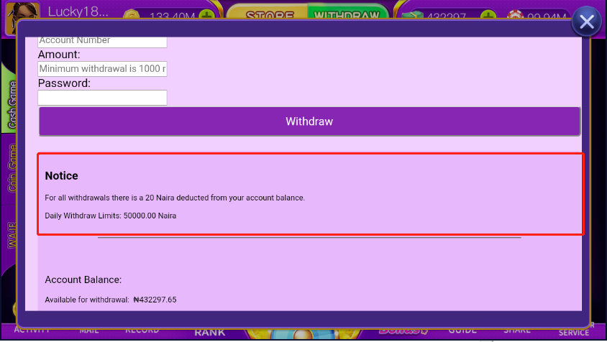
To ensure you get the best from the Waje game, and for us to be in line with the anti-money laundering authorities, please note the following;
- Withdrawal of cash from your account in the game is only available when you have topped up your account at least once.
- You can only withdraw the cash you have made in the course of playing the game. This means that once you top up your account, you get game chips and not withdrawable cash, which you can then use to play the game and win some real cash.
For all Withdrawals there is a Fee deducted from your account balance.
i) Less than N5000 attracts N10 per transaction
ii) N5001-N10000 attracts N25 per transaction
iii) N10001-N30000 attracts N25 per transaction
iv) Above N30000 attracts N50 per transaction

Daily Withdraw limits: 50000.00 Naira
Make sure you keep chopping life with Waje!

Account Balance:
Available for withdraw: xxxxxxx

