GAME RULES：页签1-WHOT
Whot：
The meaning of PowerCards: 1,2,8,14,20 FUNCTIONS/ROLES IN THE GAME
1: Hold On---Pauses all opponents' cards and let that particular player continue to play
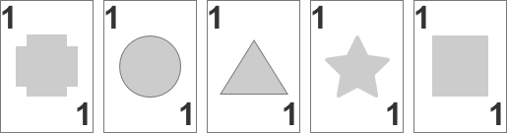
2: Pick 2---picks 2 cards if the opponent has same card it can be rejected and returned
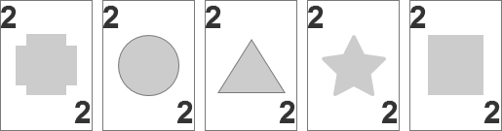
8: Suspension--- Bans the next opponent from playing
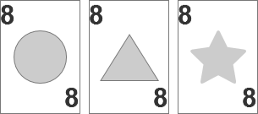
14: General Market---All opponents pick a card (compulsory pick)
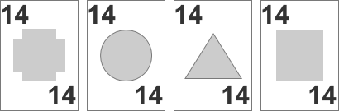
20: Waje Game WHOT---Changes the suit of the card by ‘shape', the player cannot play the card in the current round, and wait for the opponent to play the card before continuing to play
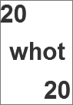
Game Rules:
The game starts with 54 cards
At the beginning of the game, each player will get 5 cards
You need to match the same shape or number
There are some PowerCards in this deck
When a player has played all hands and no cards left, this player wins
When the winner is still not decided after having been shuffled twice, all players’ hand is counted. The sum of the numbers on each player's hand is the final score, and the player with the lowest score wins
When the hand count score is average, each player randomly obtains a new card from the hand pile until there is a difference in score, and the player with the lowest score wins
Each player has 20 seconds to play his card. If the player does not take any action for more than 20 seconds, a card will be automatically added to that player
In the case of dispute, the company reserve the rights to arbitrate.

GUIDELINES：页签1-CASH
CASH：
CASH can only get from play WHOT, LucySoccer, RedorGreen and ROULETTE game
You can withdraw CASH to your assigned bank account.
Cash can be transferred among users’ accounts.
Fortune House Network LTD reserves the rights of interpretation

(cash you have) (Make some withdraws here)
1Cash=1chip

GUIDELINES：页签2-CHIP
CHIP:
CHIP can be acquired by TOP UP and getting rewards from the game
Players can use CHIP to play WHOT, LucySoccer, RedorGreen and ROULETTE game
CHIP is not withdrawable
CHIP is not transferrable
Any of prize from players won in any game bet with CHIP and CASH will be committed to CASH
Fortune House Network LTD reserves the rights of interpretation
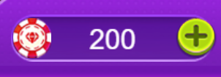
(chip you have) （Here to Top Up your wallet）
1chip=1Cash
ACTIVITY GUIDE：页签1-GAME TASKS
Game tasks:
Mission: Play two games a day
Task reward: receive 2000 CHIPS as reward after 2 games played
Note:
1. The task is valid within 24 hours and settled on the same day
2. Only valid for WHOT games
In the case of dispute, the company reserve the rights to arbitrate.
ACTIVITY GUIDE：页签2-DAILY SIGNIN
Daily sign in:
Task rule: You can receive a task reward once a day, sign in the next round of task after receiving rewards for 7 times.
Task reward: task rewards are settled daily.
In the case of dispute,the company reserve the rights to arbitrate.
ACTIVITY GUIDE：页签3-GAME RANKING
CHIP Bet Amount：
incl. chip games and roulette.
CHIP GP:
incl. chip games and roulette
Player MUST finish games. Games are not counted if you leave it unfinished.
Games are counted if your opponent leave the game unfinished.
In the case of dispute, the company reserve the rights to arbitrate.

