骰子添加guide描述
骰子游戏添加guide描述，逻辑与whot场类似
需要用到的美术资源：
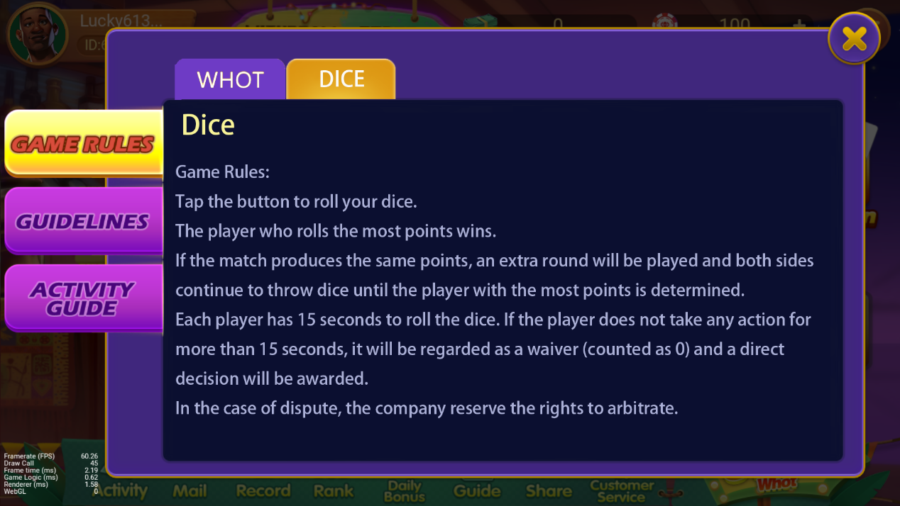
玩家在大厅界面打开GUIDE并在GAME RULE中选择DICE时显示骰子的相关文案。文案长度不能一页全部显示时可以通过手指滑动翻页。
文案：
Dice
1.Tap the button to roll your dice.
2.The player who rolls the most points wins.
3.If the match produces the same points, an extra round will be played and both sides continue to throw dice until the player with the most points is determined.
4.Each player has 15 seconds to roll the dice. If the player does not take any action for more than 15 seconds, it will be regarded as a waiver (counted as 0) and a direct decision will be awarded.
5.In the case of dispute, the company reserve the rights to arbitrate.

